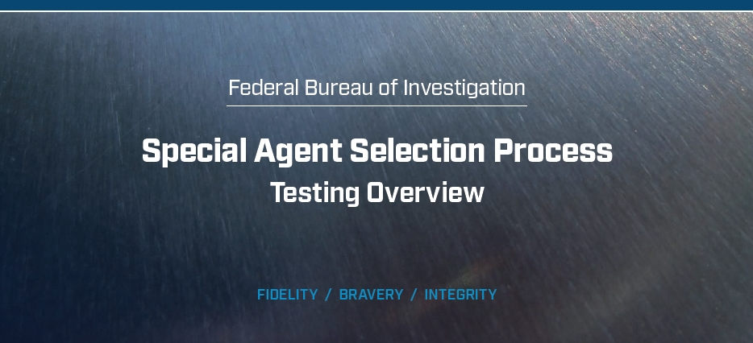



**Logistics and Guidelines**

When and Where:

Phase I testing is administered at various locations throughout the United States. The FBI has partnered with

PSI Services (PSI) to administer the Special Agent Phase I tests at local testing sites for the convenience of applicants.

Scheduling:

For Phase I, applicants will receive an invitation from PSI, on behalf of the FBI, to schedule the test. Applicants will

have up to 21 days from the date of invitation to schedule and complete the test.

What to Bring:

Candidates must bring a driver’s license to the assessment. If your driver’s license does not have a photo, you must

provide an additional form of photo identification.

What Not to Bring:

»» Reference materials (dictionaries, textbooks, etc.).

»» Pens and/or pencils (these will be provided).

»» Reading materials (books, magazines, newspapers, etc.).

»» Work-related materials.

»» Briefcases, backpacks and purses.

»» Papers (resumes, notification letters, notes, blank paper, etc.).

»» Cellular phones (alarms on watches must be turned off).

»» Other electronic devices (calculators, tape recorders, cameras, radios, etc.).

»» Firearms (if you are currently in a law enforcement position, you may not bring your firearm into the FBI space or the testing facility).

What to Wear:

Wear casual, comfortable clothing that is suitable for an office environment

Test Time:

The test takes approximately three hours.

Basic Testing Rules:

**Tardiness** — Please arrive on time. If you are late, you will not be permitted to participate in testing.

**Eating/Drinking** — Eating and drinking is not allowed during testing.

**Smoking** — Smoking and chewing tobacco are not permitted during testing.

**Restroom Use** — You may not use the restroom during administration of the tests unless it’s an emergency.

**Cellphone Use** — You are not permitted to use a cellphone during the testing process.

**Time Limits\*** — Time limits are strictly enforced. When time has elapsed, you must immediately stop what you

are doing and await further instructions. Failure to comply will result in you being disqualified from the process.

*\*Special accommodations are available for those with a disability or impairment that will require a time extension.*

**Reasonable** **Accommodations** — The FBI provides reasonable accommodations to qualified individuals with

disabilities. If you believe you have a disability that will require special arrangements during the hiring process,

you may request a reasonable accommodation at any time by notifying your Applicant Coordinator. Each test in

the hiring process is evaluated differently. Therefore, you must submit a reasonable accommodation request for

each test, if needed. The decision to grant reasonable accommodations will be made on a case-by-case basis.

**Talking** — There will be no talking to other applicants once testing has begun.

**Cheating** — Any attempt to see another applicant’s answers; obtain assistance verbally or in writing; or record,

document or otherwise retain/discuss the questions/answers to the assessments is considered cheating.

Those caught cheating are discontinued from further consideration for the Special Agent position.

**Discussing the Tests** — Candidates are not permitted to discuss any part of the tests or interview questions with

anyone during or after the testing process. We discourage discussing your prospective FBI employment on any

social media or social networking sites. You should remain discreet about your application, including all interview

and testing information, during the entire FBI hiring process. This ensures other potential applicants are not given

an unfair advantage or disadvantage in the selection process. Applicants are required to sign a nondisclosure form

prior to the assessment. If an applicant is found to have violated this agreement, he or she will be disqualified.

**Leaving the Premises** — Candidates are not permitted to leave the testing premises during testing.



**Overview:**

The Phase I test is a computerized exam that takes approximately three hours to complete.

Phase I is comprised of five assessments that measure the critical thinking and reasoning skills required to perform

the Special Agent job, as well as background experiences that indicate whether the Special Agent work environment would be a good fit. The five assessments focus on Logic-Based Reasoning, Figural Reasoning, Personality Assessment, Preferences and Interests and Situational Judgment.

The Phase I test is taken in a proctored environment offered by PSI. PSI’s web-based registration and scheduling system allows you the flexibility to select the date, time and test center near you. Be sure to read all PSI emails carefully.

Your test will be administered by PSI’s trained proctors. Proctors and testing centers are not affiliated with the FBI.

Proctors will not answer position- or test-related questions. Contact the Applicant Coordinator or a recruiter at your Processing Field Office (PFO) with any questions about the Special Agent position.

Before leaving for your scheduled appointment, check the Test Center Closures to verify that your center is open.

You need to arrive at the test center 15 minutes prior to the beginning of your Phase I test appointment. In most

cases, you will not be allowed to enter the center until 15 minutes prior to your appointment.

You may only cancel or reschedule your appointment, without penalty, up to 48 hours before your scheduled

appointment.

**Phase I Expirations:** Applicants are limited to two invitations before being deactivated unless a valid reason is

provided. Applicants must wait a minimum of 90 days from the expiration date before a new invitation will be issued.

Applicants who allow two Phase I invitations to expire without providing acceptable explanations will not be offered

other opportunities to test and will be permanently deactivated from the Special Agent Selection System (SASS).

**Phase I No-Shows:** Applicants are limited to two no-shows before being deactivated unless a valid reason is

provided. Applicants must contact their Field Office Applicant Coordinator as soon as possible and provide a

written statement that details the reason for not taking the Phase I test. The FBI will ascertain the facts and

circumstances regarding an applicant’s failure to report for Phase I testing. If the reason is deemed acceptable, the

FBI will reschedule the applicant for testing. If the reason is not deemed acceptable, the applicant will be deactivated.

If there is a major test disturbance (power or internet outage, fire drill, etc.) declared by PSI, you may be given

the option to reschedule. If you have any concerns, contact your local Field Office Applicant Coordinator or

recruiter immediately.

Applicants who do not pass Phase I are eligible to retest 90 days after their final test session. Applicants who fail the

Phase I Test twice will be deactivated and ineligible for future consideration for the Special Agent position.

**Test-Taking Tips:**

Before the Test Session:

»» Plan so you are well-rested before the test session.

»» Make sure you know the exact location and time of the test session, allow plenty of time to get to the test site use the restroom and relax.

»» Wear something comfortable; test sites may be slightly warm or cool so dress for a range of temperatures.

»» Reduce test anxiety and tension by breathing deeply and stretching before the test.

»» Start the test session with a positive attitude, determination to do your best and focus on what you do know, not on what you do not know

During the Test Session:

»» Read all the test instructions carefully and follow them exactly.

»» Be sure you understand the test instructions before you start, if you need to ask questions, do so.

»» Read each question and all the response options completely before choosing your answer.

»» Be careful not to add or skip any words in the question or response choices.

»» Pay attention to words like NOT and EXCEPT.

»» Do not over-interpret questions or try to find hidden meanings, the questions are not designed to be tricky.

»» If you have time remaining at the end of a test, proofread your answers.

»» Try to stay relaxed; if you have trouble concentrating or become tense, pause and take a few deep breaths.

**Phase I Test Components:**

The Phase I Test is comprised of five assessments that measure critical thinking and reasoning skills, as well as

background experiences that indicate whether the Special Agent work environment would be a good fit.

The five assessments focus on Logic-Based Reasoning, Figural Reasoning, Personality Assessment, Preferences

and Interests and Situational Judgment.

**Important:** Do not attempt to “beat the test” by claiming qualities or experiences that you do not really have. Clearly, the FBI does not wish to hire candidates who provide unrealistic or false responses. If, during later portions of the hiring process, such as a background check, the FBI determines that you falsified your responses at any point in the Special Agent Selection System, you may be permanently barred from employment.

Logic-Based Reasoning:

The Logic-Based Reasoning Test assesses your ability to read a set of facts and use problem solving and reasoning skills. You must draw logical conclusions about the inferences that can and cannot be made based on the presented facts. The questions in this section consist of a short paragraph followed by a multiple-choice question which requires interpretation of the information in the paragraph. Based on the information provided, test takers must choose the correct answer from five multiple choice options. No pen and paper or calculations are necessary to identify the correct answer.

**Duration:** This section contains 11 questions.

**Preparation:** Thoroughly read through the descriptions, statements and questions. Read carefully and attentively. Use the information from the description ONLY; do not introduce outside information to make the final selection. Pay attention to words such as MUST or ONLY and answer accordingly.

**Types of Statements:**

**»»** **“All” Statements:**

Statements that include the word “all” or “every” indicate that the facts that apply to one group also apply to another group. However, the statement does not allow you to infer that the facts that apply to the second group also apply to the first group.

***Example Statement:*** *All employees in the payroll department work part time.*

***Invalid Inference:*** *All part-time employees work in the payroll department.*

***Valid Inference:*** *Some part-time employees work in the payroll department.*

**»»** **“No” Statements:**

Statements that include the word “no” or “none” indicate that the facts that apply to one group do not apply to

another group. “No” statements allow you to infer that there is no overlap between the two groups.

***Example Statement:*** *None of the employees in the payroll department play on the company softball team.* ***Invalid Inference:*** *Some of the members of the company softball team, work in the payroll department.*

***Valid Inference:*** *None of the members of the company softball team, work in the payroll department.*

**»»** **“Some” Statements:**

Statements that include the word “some,” “many” or “few” indicate that the facts presented only apply to a portion

of the groups/people in one group. “Some” statements do not allow you to make inferences about the remaining

people in the group.

***Example Statement:*** *Some of the employees in the payroll department also work from home.*

***Invalid Inference:*** *Some of the employees in the payroll department do not work from home.*

***Valid Inference:*** *Some of the employees who work from home are in the payroll department.*

**»»** **“If-then” Statements:**

Statements that include “If-then,” “whenever” or “every time” provide information about sequence of events.

“If-then” statements do not allow you to reverse the order of the statements. Additionally, in order to negate

the sequence of events, both events must be negated.

***Example Statement:*** *If the employees in the payroll department finish their work, then they can take Friday off.*

***Invalid Inference:*** *If the employees in the payroll department take Friday off, then they can finish their work.*

***Invalid Inference:*** *If the employees in the payroll department do not finish their work, they can take Friday off.*

***Valid Inference:*** *If the employees in the payroll department do not finish their work, they cannot take Friday off.*

**Sample Questions:**

Shannon is in the produce section of her grocery

store and she asks about the general cost differences

**A** Blueberries are the cheapest fruit available.

**B** Bananas are cheaper than raspberries.

**C** Blueberries are more expensive than bananas.

**D** Raspberries and grapefruits are the same price.

**E** Oranges are less expensive than grapefruits.

across the various types of produce. If she learns

that the below statements are factual, which of

the response options also MUST be true?

*Bananas are cheaper than oranges.*

*Blueberries are cheaper than raspberries.*

*Raspberries are more expensive than oranges.*

*Grapefruits are more expensive than blueberries.*

**Correct Answer**

Based on the information provided, raspberries are more expensive than oranges and oranges are more

expensive than bananas. Oranges are the key piece of information that provides enough information

to compare raspberries and bananas. With this information, the statement that raspberries are more

expensive than bananas is the accurate choice (Option B).

**Sample Questions:**

There has been a rash of money laundering cases in a

**A** Some money laundering investigations valued

under 1 million dollars are overseen by Team A.

**B** None of the money laundering investigations are

valued under 1 million dollars.

**C** Some money laundering investigations are not

valued under 1 million dollars.

**D** Every money laundering case valued over 1 million

dollars are overseen by Team A.

**E** None of the money laundering cases valued under

1 million dollars are cases handled by Team B.

region. These cases are overseen by either

Team A or Team B. Cases that are valued under 1 million dollars will not be overseen by Team A. Some of the investigations will be overseen by Team A.

Based on the information above, which of these

statements MUST be true?

**Correct Answer**

The correct answer is C. Based on the information provided in the passage, Team A will not oversee cases

valued under 1 million dollars. In other words, Team A will oversee cases valued at 1 million dollars or greater.

Meanwhile, there is less explicit information about what Team B is doing. Therefore, C is the correct response.

****Figural Reasoning:

The Figural Reasoning Test assesses your ability to use problem solving and reasoning to identify the shape or

image that logically fits the pattern. The Figural Reasoning questions contain images that include a sequence of

shapes and patterns. As seen in the sample multiple choice questions below, one section of the arrangement is

missing. Your goal is to determine the next picture that logically fits within the pattern. Patterns may follow the

three rows or columns, and may involve any aspect of the figures, including shape, color, number of shapes or

sides, or other characteristics.

**Duration:** This section contains nine questions.

**Preparation:** Comprehensively review the sequenced shapes and patterns. Take a moment to determine the

arrangement. Recheck your selection before moving on to the next sequence.

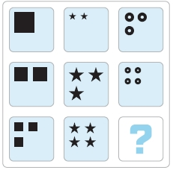**Sample Questions:**



**A** **B** **C** **D** **E**

**Correct Answer**

The correct answer is B. The pattern adds one of each shape to each row across columns. For example, the left column—in descending order by row—is made up of one square, then two squares, then three squares. The middle column—in descending order, is made up of two stars, then three stars, then four stars. As the right column contains circles, B is the only option that satisfies that pattern. The other possible pattern is to solve by row. The top row—from left to right by column—is made up of one square, then two stars, then three circles. The middle row—from left to right—is made up of two squares, then three stars, then four circles. Again, B is the only response option that satisfies that pattern.

**Sample Questions:**



**A** **B** **C** **D** **E**

**Correct Answer**

Two shapes in each row are combined—or laid over each other—to create a new shape. Overlapping shapes

are eliminated so that only the unique blocks from the two shapes remain. For example, in the top row, the

second and third pictures combine and make the first picture. In the second row, the first and third images

combine to make the second/middle image. C is the only shape that fits this pattern as it is a combination

of both shapes in the bottom row.

****Personality Assessment:

The Personality Assessment measures aspects of your personality to identify those that possess traits necessary

to be a successful Special Agent. You will be presented with five pairs of statements on each screen. You will be

asked to use the slider to indicate the degree to which you agree with one of the two statements. This test is

adaptive, so your responses on the previous questions will be used to determine the next set of questions

you are presented with. Note that you will not be able to choose a neutral position.

**Duration:** This section contains 100 statements.

**Preparation:** Read each statement completely and carefully. At times, it may be hard to choose because you

agree or disagree with both statements. This is a normal part of the assessment. This section does not contain

any explanatory answers, as the answers are based on your personal characteristics.

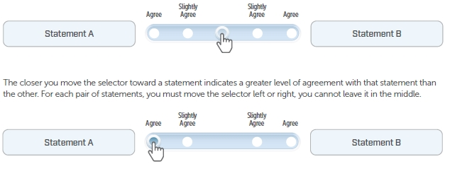

**Sample Questions:**

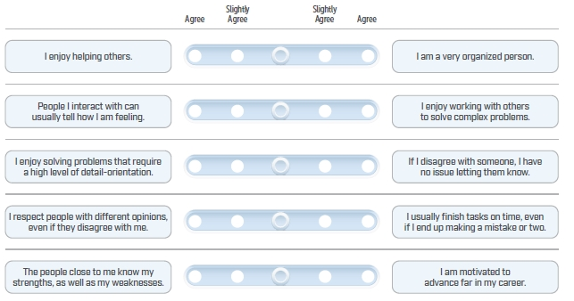

****Preferences and Interests:

The Preferences and Interests Test gathers information about your personal attitudes toward a variety of statements.

Like the personality assessment, this test identifies those that possess the dispositional qualities to be successful

as a Special Agent. You will be presented with a statement and a rating scale with five response options ranging

from “Strongly Agree” to “Strongly Disagree.” Choose the response option that most closely indicates your level

of agreement with the statement.

**Duration:** This section contains 37 questions.

**Preparation:** Do not dwell on the statements. Answer with the response option that reflects your agreement with the

statement. Try not to “read into” the statement. Remember to choose the option that most accurately describes you.

**Sample Questions:**

**A** Strongly Agree

**B** Agree

**C** Neither Agree nor Disagree

**D** Disagree

**E** Strongly Disagree

I tend to lose interest when attempting to pay attention to small detail for a long period of time.

**A** Strongly Agree

**B** Agree

**C** Neither Agree nor Disagree

**D** Disagree

**E** Strongly Disagree

When working on a team, it’s more important to ensure

the work product exceeds expectations than it is to

make sure everyone is doing the same amount of work.

****Preferences and Interests:

The Situational Judgment Test measures your judgement in response to everyday situations. You will be presented with various scenarios, each of which will have five response options to choose from. The scenarios describe situations and problems that you are likely to encounter in a typical work environment. Each response option will propose a different way of responding to the scenario. You should choose the response option that is most consistent with how you would respond.

**Duration:** This section contains 19 questions.

**Preparation:** Do not dwell on the statements or scenarios. Answer with the statement that closely reflects how it applies to you. Try not to “read into” the statement. Remember the choice is not right or wrong, but instead what is best for you.

**Sample Questions:**

**A** Inform your manager that your co-worker

did not complete his part of the project.

**B** Respond by asking that your co-worker set

aside other tasks to complete his task on time.

**C** Submit your completed work along with your

co-worker’s incomplete work.

**D** Finalize the work your co-worker was asked to complete

so that the new process is implemented on time.

**E** Ask your manager to extend the deadline.

You and a co-worker are developing guidance

materials covering how to properly file and update

issues into a new tracking system. The materials are

important, as they will be distributed to the broader

team. You completed your project tasks. However,

your co-worker informed you today that while he is

close to finishing, he is unable to complete the task

due to other project commitments. Which of the

following would you be MOST likely to do?

**A** Join a project team with senior leaders so you

have an opportunity to make a good impression.

**B** Join a project review task force that helps to ensure

that the organization is meeting public needs.

**C** Decline the opportunity so that you can focus

on your workload.

**D** Join a project that has a light workload so that it

doesn’t disrupt your current work schedule.

**E** Join a team with people that you don’t know

so, you can expand your network of colleagues.

There are a variety of specialized teams with different

initiatives at your organization. Your current supervisor

has given you the opportunity to join one project

outside of your immediate team in order to gain

exposure to other parts of the organization. Which

one of the following options are you most likely to do?

**Practice Test:**

This section is a practice test, which includes questions like those on the actual Phase I test. Once you

complete the test, you can check your answers on the cognitive items (Questions 1–20) using the answer key

provided at the end of this guide. Questions 21–50 are not included in the answer key as they are dependent

upon personal characteristics.

For Questions 1–10, choose the response option that best answers the question using only the information

presented in the scenario.

1. A consulting firm has established a new recruiting policy to reduce travel expenses for applicants. However, applicants who live within a 25-mile radius of a company office are not eligible to interview virtually. Specifically, some applicants now interview with a recruiter virtually, using videoconferencing equipment.

Based on the information above, which of these statements MUST be true?

**A** Some applicants who live within a 25-mile radius of a company office are eligible to interview virtually.

**B** A few applicants who live within a 25-mile radius of a company office do not interview virtually.

**C** None of the applicants interview with a recruiter virtually.

**D** All of the applicants interview with a recruiter virtually.

**E** None of the applicants who live within a 25-mile radius of a company office are eligible to interview

with a recruiter virtually.

1. Due to the size of its workspace, a bakery is only able to produce a few of its products on any given day. It makes four specialty items, but only focuses on two for any one day. Based on the information above, which of these statements MUST be true?

*Breads are produced on Mondays and sold throughout the week.*

*Cupcakes are made on Mondays, Wednesdays, and Fridays.*

*Pastries cannot be made on the same days as cupcakes.*

*Cookies and pastries are always made on the same day.*

Which of the following can be made on the same day?

**A** Breads and cookies.

**B** Cupcakes and breads.

**C** Cookies and cupcakes.

**D** Pastries and breads.

**E** Cupcakes and pastries.

1. ****The Board of Directors of a public company is considering an acquisition of a highly sought-after company

in a very niche market. For the decision to be approved, it must request approval from its shareholders before 1:00 p.m.

Based on the information above, which of these statements MUST be true?

**A** If the company was acquired, the Board of Directors must have made its request for approval after 1:00 p.m.

**B** If the company was acquired, the Board of Directors must have made its request for approval before 1:00 p.m.

**C** If the company was not acquired, the Board of Directors must not have made a request for approval.

**D** If the company was not acquired, the Board of Directors must have made its request for approval after 1:00 p.m.

**E** If the company was not acquired, the Board of Directors must have made its request for approval before 1:00 p.m.

1. A restaurant specializes in freshly sourced ingredients. The restaurant chef can only purchase the ingredients

for their menu according to what is available on specific days at the local market. The restaurant offers five

different dishes every week. Based on the guidelines stated below, what are the three food options that can

be served on any Tuesday?

*Grilled asparagus and lemongrass salad may be served any day except for every other*

*Tuesday and every other Thursday.*

*Pasta primavera with garlic bread can be served only on Mondays and Wednesdays.*

*Blackened sea bass with quinoa can be served on Tuesdays, Wednesdays and Fridays.*

*Barbecued chicken with garbanzo beans cannot be served on Fridays.*

*Sautéed mushrooms in garlic sauce cannot be served on Wednesdays.*

**A** Pasta primavera with garlic bread, blackened sea bass with quinoa and sautéed mushrooms in garlic sauce.

**B** Barbecued chicken with garbanzo beans, sautéed mushrooms in garlic sauce and blackened sea bass

with quinoa.

**C** Grilled asparagus and lemongrass salad, barbecued chicken with garbanzo beans and pasta primavera

with garlic.

**D** Sautéed mushrooms in garlic sauce, barbecued chicken with garbanzo beans and pasta primavera

with garlic bread.

**E** Barbecued chicken with garbanzo beans, grilled asparagus and lemongrass salad and blackened

sea bass with quinoa.

1. The controller’s office is allotting funds to both the federal and state road departments. Funds will be allocated

based on the jurisdiction of each road in a given state. In reviewing the records, the controller’s office found that every toll road is under the jurisdiction of the federal road department. Some of the toll roads are also under the

jurisdiction of the state road department. What MUST be true?

**A** All of the toll roads that are under the jurisdiction of the federal road department are under the jurisdiction

of the state road department.

**B** All toll roads that are under the jurisdiction of the state road department are under the jurisdiction of the

federal road department.

**C** None of the toll roads that are under the jurisdiction of the state road department are under the jurisdiction

of the federal road department.

**D** Some toll roads that are under the jurisdiction of the federal road department are not under the jurisdiction

of the state road department.

**E** Several toll roads that are under the jurisdiction of the state road department are not under the jurisdiction

of the federal road department.

****6. A law firm has recently changed its policy about the length of time certain client communications must be retained after a case is closed. All notarized documents are part of the new document retention policy. None of the documents that are mailed to a client using noncertified mail is a notarized document. What MUST be true?

**A** Every notarized document is sent to the client using noncertified mail.

**B** Every document that is not notarized is sent to a client using noncertified mail.

**C** Any document that is notarized is not a document that is sent to a client using noncertified mail.

**D** No document that is mailed to the client using certified mail is not a notarized document.

**E** Every document sent using noncertified mail is a notarized document.

7. A Risk Management Officer is evaluating the type of business vendors in its vendor tracking system (VTS). Each vendor in the VTS is a private limited liability company (PLLC). None of the companies in the VTS is funded through private investors. What MUST be true?

**A** Every company in the VTS that is funded through private investors is a PLLC.

**B** Any PLLC in the VTS is a company that is not privately funded.

**C** Some companies in the VTS that are funded through a private investor are a PLLC.

**D** Every company in the VTS that is not a PLLC is funded through a private investor.

**E** PLLCs in the VTS are funded through a private investor.

8. Any employee on the web design team has received at least one design industry award for his or her work.

Several of these employees have received an award from *Dzyne* Magazine. What MUST be true?

**A** All employees on the design team have received an award from *Dzyne* Magazine.

**B** Some employees on the design team who received a *Dzyne* Magazine award have not received

a design industry award.

**C** A few employees on the design team who have received an industry award have received an award

from *Dzyne* Magazine.

**D** Employees who have not received a *Dzyne* Magazine award have not received a design industry award.

**E** Employees on the design team who have not received an industry award have received a

*Dzyne* Magazine award.

9. A work team is considering adding another member and just concluded their interview process of five

candidates. The five candidates are Frederick, Katherine, Stella, Jameson and Paul. The existing work team

came to consensus on the rank order of the five candidates. According to the below information, which

candidate did the team rank second.

*Frederick was ranked in the lower 50%.*

*Stella outscored Jameson, but not Paul.*

*Katherine was the highest ranked but is taking a role in another division.*

*Jameson was not the lowest ranked candidate.*

**A** Fredrick

**B** Katherine

**C** Stella

**D** Jameson

**E** Paul



10. David is planning to take some time off to go on an extended vacation. His boss will approve the vacation request if David finishes his current project. If his boss approves the request, then he will be able to take the vacation that he wants.

**A** If David does not finish his current project, he cannot go on vacation.

**B** If David can go on vacation, then he may not have finished his current project.

**C** If David has finished his current project, then he can take his vacation.

**D** If David is not allowed to go on vacation, then he finished his current project.

**E** If David can go on vacation, then he did not finish his current project.

For Questions 11–20, choose the pattern that completes the sequence.

11.



**A** **B** **C** **D** **E**

****12.



**A** **B** **C** **D** **E**

13.



**A** **B** **C** **D** **E**

****14.



**A** **B** **C** **D** **E**

15.



**A** **B** **C** **D** **E**

****16.



**A** **B** **C** **D** **E**

17.



**A** **B** **C** **D** **E**

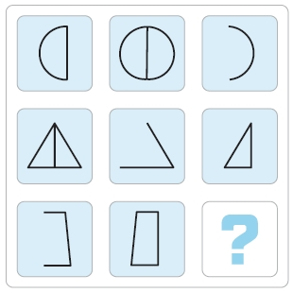****18.



**A** **B** **C** **D** **E**

19.



**A** **B** **C** **D** **E**

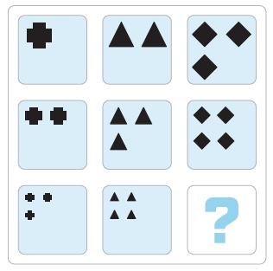****20.



**A** **B** **C** **D** **E**

For Questions 21–30, choose the response option that most closely reflects your level of agreement with the statement.

1. If I did not have enough time during my work hours, I would sacrifice my own personal time to ensure the quality of my work.

**A** Strongly Agree

**B** Agree

**C** Neither Agree nor Disagree

**D** Disagree

**E** Strongly Disagree

1. Others may find it difficult to work with me because I can be meticulous about the details.

**A** Strongly Agree

**B** Agree

**C** Neither Agree nor Disagree

**D** Disagree

**E** Strongly Disagree

1. ****I put less effort and attention into activities at work that I find boring.

**A** Strongly Agree

**B** Agree

**C** Neither Agree nor Disagree

**D** Disagree

**E** Strongly Disagree

1. I enjoy the sense of satisfaction that comes from pushing myself to accomplish a difficult task.

**A** Strongly Agree

**B** Agree

**C** Neither Agree nor Disagree

**D** Disagree

**E** Strongly Disagree

1. I never submit anything unfinished, even if it means putting extra time and effort to meet a tight timeline.

**A** Strongly Agree

**B** Agree

**C** Neither Agree nor Disagree

**D** Disagree

**E** Strongly Disagree

1. If I notice that someone seems stressed or anxious, I try to talk to him/her to improve their mode and make his/her day better.

**A** Strongly Agree

**B** Agree

**C** Neither Agree nor Disagree

**D** Disagree

**E** Strongly Disagree

1. When in a group setting, I can read the body language of others and recognize when people are not in agreement.

**A** Strongly Agree

**B** Agree

**C** Neither Agree nor Disagree

**D** Disagree

**E** Strongly Disagree

1. When someone does not share my point of view, I tend to openly confront the disagreement.

**A** Strongly Agree

**B** Agree

**C** Neither Agree nor Disagree

**D** Disagree

**E** Strongly Disagree

1. ****I enjoy holding spontaneous conversations with the people I work with.

**A** Strongly Agree

**B** Agree

**C** Neither Agree nor Disagree

**D** Disagree

**E** Strongly Disagree

1. I find it difficult to maintain and active interest in the problems of other people.

**A** Strongly Agree

**B** Agree

**C** Neither Agree nor Disagree

**D** Disagree

**E** Strongly Disagree

For Questions 31–40, choose the response option that most closely reflects how you would respond to the scenario.

1. An elderly neighbor stops you and inquires if you can assist her in shoveling snow from her driveway. You are

cognizant that if you stop to assist her you will be late for a meeting at work. How would you handle this situation?

**A** Suggest she asks the teenager next door to help her.

**B** Go next door and pay the teenager living there to help her.

**C** Apologize to her and explain that you are running late for work.

**D** Assist her and explain the situation to your boss.

**E** Pretend that you did not hear her and carry on your way.

1. One of your colleagues approaches you and requests your help in planning the annual holiday celebration. You

have an extensive workload so aren’t certain that you are available to contribute. What would you do in this situation?

**A** Reprioritize your work so you can assist with the party.

**B** Assist with the party planning on your own time.

**C** Decline to help, saying that you can’t take on any more work.

**D** Inform your colleague that you’re not a good party planner.

**E** Agree that you’ll help if you’re able to lighten your workload.

1. Several weeks ago, you submitted a lengthy report to your supervisor who praised the thoroughness of

your work. After rereading the report yesterday, you realize that you made a small error. However, no one

else noticed the mistake and the report has already been filed. In addition, your team is currently working

on a different, time-sensitive assignment. Which of the following actions are you most likely to take?

**A** Complete your current assignment before correcting the error.

**B** Notify your supervisor of the error and send them a corrected document.

**C** Continue with your work without addressing the error as it would only make more work for your supervisor.

**D** File a corrected document directly without notifying your supervisor.

**E** Ask a colleague to correct and resubmit the report on your behalf.

1. ****One of your colleagues, who is dealing with personal issues, has started coming in to work late and his

performance has declined. Your supervisor asks you to explain why the performance of your team is down. How are you most likely to respond?

**A** Explain your colleague’s situation to your supervisor and ask her how to proceed.

**B** Tell your supervisor that it is temporary and talk to your colleague about his performance.

**C** Take personal responsibility for the decrease in performance.

**D** Ask your supervisor to talk to your colleague.

**E** Talk to the rest of your team about the situation and figure out how you can all work together

to cover for your colleague’s responsibilities.

1. One of your teammates, who is often late to work, criticizes you for a minor rule infraction and files a complaint

with your supervisor. Your supervisor then asks you to explain yourself. Which of the following actions are you

most likely to take?

**A** Point out that the person complaining is often late to work.

**B** Accept the criticism and talk to your teammate.

**C** Work out the situation with your teammate on your own.

**D** Apologize to your supervisor and assure her that you take the rules seriously.

**E** Accept the criticism and work toward reducing the cause of the complaint.

1. A colleague of yours is going through a tough divorce. He has been showing up for work late, leaving early,

and handing off his work assignments to other people. His supervisor comes to you and asks if you’ve

noticed any of these issues. Which one of the following actions are you most likely to take in this situation?

**A** Deny any knowledge of inappropriate behavior.

**B** Tell his supervisor that it’s none of your business and you don’t want to be caught in the middle.

**C** Tell his supervisor only what you have directly observed, leaving out anything you’ve heard from others.

**D** Tell his supervisor that you don’t feel right talking about the situation until you talk to your colleague first.

**E** Ask if you can discuss the issue later, then go to your colleague and let him know what’s happening.

1. You notice that a co-worker smells like alcohol after he returns from lunch each day. You are uncertain about

whether or not he is consuming alcohol and, if he is, you have no reason to believe it’s impacting his

work performance. Which of the following actions are you most likely to take?

**A** Do nothing because it is none of your business and you shouldn’t get involved.

**B** Tell some of your coworkers and hope that one of them does something about it.

**C** Speak directly to the individual and express your concerns.

**D** Report the situation to your supervisor so she can address the issue.

**E** Look into the situation further to determine if your co-worker is indeed drinking at lunch.

1. You have been experiencing severe financial difficulties, so you search for a part-time job to supplement your

income. After searching for several weeks, you learn about a great opportunity; however, the job is with a competitor

of your full-time employer. Which one of the following actions are you most likely to take in this situation?

**A** Look into the part-time opportunity further so you have more information on which to base a decision.

**B** Ask your boss for a raise so you don’t need two jobs.

**C** Follow up on the part-time opportunity and take the job if it’s offered to you.

**D** Explain the situation to your boss and ask for her permission to pursue the part-time opportunity.

**E** Disregard the opportunity and continue to search for another part-time job.

1. ****It has been a very busy month for everyone in your department and everyone has been working more hours

than usual. At the end of a particularly long day, your supervisor mentions that there is a potential problem in

a report being prepared for distribution to other departments in the organization. Which one of the following

options are you most likely to do?

**A** Send a note to your colleagues informing them that they may need to double check their work.

**B** Wait until the next day to schedule a meeting with members of the project team, then investigate

the issues in more detail.

**C** Ask your supervisor to clarify the potential problem with the report and immediately begin

generating options to address the issue.

**D** Allocate time to investigate the potential problem if your supervisor asks for your help.

**E** Ask people to stay late and review all the documents for errors.

1. Your manager has assigned a few minor tasks that need to be completed but are not directly related

to the team’s largest project. Her attention is solely focused on these larger projects and she just expects

these minor assignments to be completed by others. With a full workload, these minor assignments are not

the most time sensitive of all your responsibilities. Which one of the following options are you most likely to do?

**A** Begin working longer hours to ensure that these minor assignments can be completed as soon as possible.

**B** Delay putting effort into these minor assignments until they can’t be ignored.

**C** Rearrange your daily schedule so that you can incorporate these minor assignments into your agenda.

**D** Only work on these minor assignments when you happen to have additional free time at work.

**E** Focus primarily on these minor assignments instead of other responsibilities so that you can

get them out of the way.

For Questions 41–50, choose your level of agreement with one of two statements presented in each question.

You will darken one circle for each question. During the computerized administration of Phase I, you will move

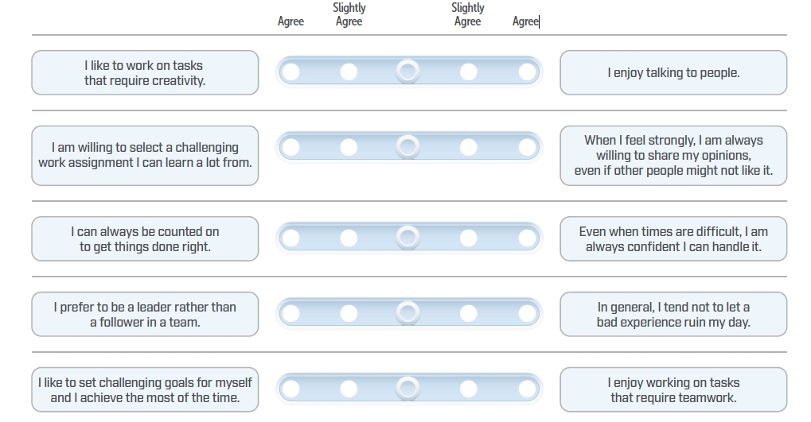a slider toward the statement with which you agree more.

1. **A screenshot of a cell phone

   Description automatically generated**

**Practice Test Answer Key:**

Please review the answer key for questions 1–20, including explanations of the correct answers for each question.

*Note: There are no correct or incorrect answers for questions 21 through 50; therefore, an answer key is not provided for these questions.*

**E** We know from the information provided that although some applicants can interview with a recruiter virtually, none of the applicants who live within a 25-mile radius of the company can interview with a recruiter virtually. Therefore, E is the correct response.

**B** We are told that only two food items can be made in the same day. According to the information provided,

we know that bread is produced on Mondays and that cupcakes are made on Mondays, Wednesdays, and Fridays. Since both bread and cupcakes are made on Mondays, the correct response is B.

**B** We are told that for the company to be acquired, the Board of Directors must make their request for approval before 1:00 p.m. This conditional statement is the key piece of information here. We know that if the company was acquired, the Board of Directors had to have made their request for approval before the 1:00 p.m. deadline. Therefore, B is the correct answer.

**B** Based on the question, we should look for foods that can be served on Tuesdays. Sautéed mushrooms in garlic sauce can be served on all days except for Wednesdays and barbecued chicken with garbanzo beans can be served on all days except for Fridays. Therefore, we can determine that both foods can be served on Tuesday. We are also told explicitly that blackened sea bass with quinoa can be served on Tuesday. Based on this information, we can deduce that B is the correct response.

**B** We know, based on the provided information, that the federal road department has control of all the roads. In addition to being controlled by the federal government, some of these roads are also controlled by the state road department. Given this information, we can infer that because the federal road department has control of all roads, and that the state road department also controls some of those roads, the federal road department controls all the roads that the state road department controls. Therefore, B is the correct response.



**C** We know from the question that none of the documents that are mailed to the client using noncertified mail is a notarized document. Based on this we can infer that any noncertified mail that is sent to the client is not a notarized document. Therefore, C is the correct response.

**B** Based on the information provided, here is what we know: All vendors in the vendor tracking system (VTS) are private limited liability companies (PLLC). We also know that none of the vendors that are a part of the VTS are funded through private investors. In other words, all VTS companies are PLLCs and none of the companies are privately funded. Therefore, none of the PLLCs in the VTS receive private funding. Therefore, the correct response option is B.

**C** We know that all employees on the team have received an award from within their industry. Of these employees, some have also received the *Dzyne* Magazine award. Based on this information, the correct response is C.

**E** We know from the information provided that although Jameson was outscored by Stella, he was not the

lowest-ranked candidate, leaving Frederick to be ranked the lowest. We also know that Stella was outranked

by Paul. Given that we are explicitly told that Katherine had the highest score, we can determine that Paul

must have been ranked second, making E the correct response.

**C** We are told that if David finishes his current project, then his boss will approve his vacation request,

which then allows David to take his vacation. Given that we are explicitly told that the middle statement

is true, we can deduce that if David has finished his project, then he can go on his vacation, making

answer C the correct response.

**B** In this image, we see that each row has one of each shape and that each shape is rotated an additional

45 degrees from the previous row. Based on this information, B is the correct response.

**B** In this image, we see that each row has the same shape, but that the size and color of that shape

are varied across columns. Based on this pattern, B is the correct response.

**E**  In this image, the small squares on the outside of the large square represent positive numbers, while the

small squares on the inside of the large square represent negative numbers. Column 3 is the sum of

columns 1 and 2. Based on this logic, if we combine 4 (the number of squares on the outside of the square)

and -6 (the number of squares on the inside of the square), we are left with -2. Since E is the only option

that has 2 squares inside the square, this is the correct response.

**C**  In this image, the number of figures in the first and second column are multiplied. This value is then

subtracted by the number of figures in the second column, which equals the number of figures in the

third column. For example, in the top row, the first column has 4 figures, the second column 3 figures.

When multiplied, this expression equals 12. 12 minus 3 (the number of figures in column 2) equals 9.

Applying this same logic to the bottom row, multiplying 2 by 1 equals 2. Subtracting 1 from 2 leaves

you with 1, making C the correct answer.

**D**  In this image, the number of horizontal lines is added to the number of vertical lines in the first column.

Then, the number of dots on the inside of the circle is subtracted from the number of dots on the outside

of the circle in the second column. The value in column 1 is then divided by the value in column 2 to

determine the number of sides the shape in column 3 will have. Based on this information, D is the

correct response.

**D**  In this image, if we subtract the number of sides in the first column from the number of sides in the

second column, we are left with the number of lines in the third column. Based on this information,

D is the correct response.

**B**  In this image, if we divide the number of lines in the first column by the number of sides in the second column, we are left with the number of dots in the third column. Based on this information, B is the correct response.

1. 

**B**  In this image, combining two of the simpler shapes within each row works to create the most complex

shape within that same row, making B the correct response.

**C**  In this image, the shape remains consistent across the row. Additionally, the color remains consistent

down the column. What changes, however, is the placement of the dot. The dot rotates, clockwise,

to the next side of the shape. Based on this information, C is the correct response option.

**E**  There are two ways to solve this pattern. Within each row from left to right, each column adds one more

shape from the preceding column, while the size of shapes remains constant within each row. In the bottom

row, Columns 1 and 2 have 3 and 4 figures, respectively. The number of shapes in the bottom right square

must be 5, making E the correct response. The number of shapes within each column also increases by 1

for each row from top to bottom. E is also the only option that satisfies this pattern.